**HOW TO: Using FindTime in Outlook to Poll Staff Availability.**

FindTime is an add-in to Outlook [that must be installed](https://findtime.microsoft.com/) first. It allows you to poll staff members via email to determine the best time to schedule a meeting.

Start in Outlook Calendar view. Click the calendar button on the bottom left  and then select New Meeting



This will bring up the regular meeting scheduler interface. Name the meeting, select a location and then add required and optional staff attendees as per usual. Fill in all the information you need in here including agenda notes and a link to web conference before proceeding. Do not set a time. Do not send the invite.

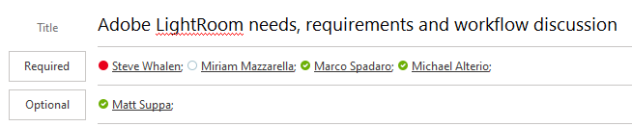

Find the “New Meeting Poll” button on top of the New Meeting screen and click it.



Upon the initial use of this tool you will need to log into your Office365 account to connect your client with the server. Click the “Link now” button and enter your account information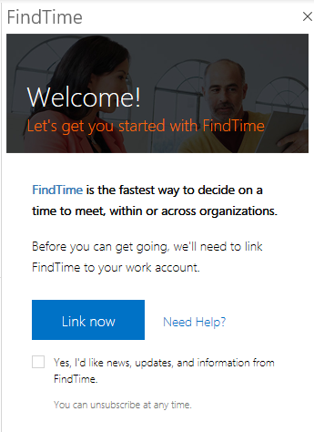

Once you have successfully connected your account, the poll interface will display with time slots and your selected attendees represented by a green (if they are free) or red (if they are booked) icon next to each slot. Select the blue slots that work for you AND have green icons representing your invitees. This will guarantee an accurate poll result. For best results pick 4-5 slots to avoid too many choices.

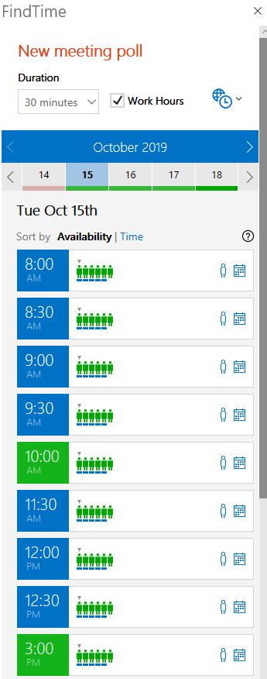

You can change the day across the top bar and the result will show as many times that every *required* attendee is available. Select up to 5 common free times. Now the vote can commence on which of the common free times is best for everyone. Once you have made your selection click the SEND button and an email invitation. It will automatically contain all your invitees and the invitation to take the poll. Please fill in the body of the email with a line about the meeting as seen below.

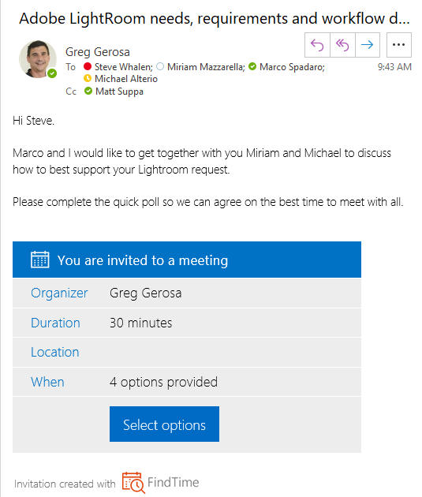

Once you send this message the poll will begin. Each attendee gets this email and the opportunity top pick their most favored time and a secondary one.

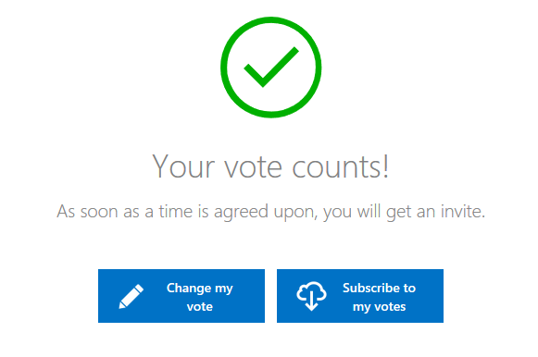

The system then tallies all the results and then will automatically schedule the meeting for all.